ro – solution

The problem is solved by using a tree decomposition of the graph, induced by its biconnected components and critical nodes. The following image describes the tree decomposition of such a graph, in order to give you a clearer picture of this.
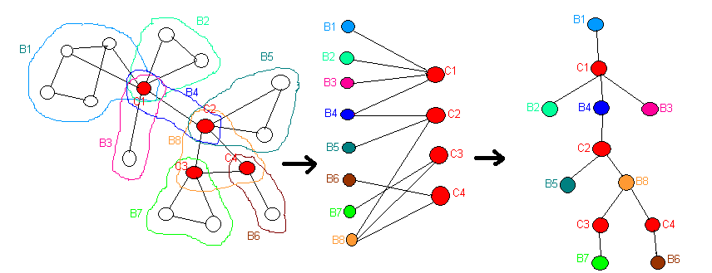

As such, in this tree, we have alternate levels of nodes represented by biconnected components and critical nodes. For simplification, we will treat each node of the tree as a subgroup of the graphs nodes. A critical node can be part of more than one such subgroups, and a non-critical node can be part of only one such subgroup. A graph edge is included in a single bi-connected component, therefore 2 nodes, u and v, will be together in at most one such subgroup corresponding to a tree node.
The problem demands the determination of a subgroup of graph nodes "covering" all edges (namely each edge has at least one of its extremities in this subgroup).
For each tree node we will calculate VMIN[C], with the following meaning: the minimum value of a subgroup of selected nodes that "covers" all graph edges corresponding to the current node of the tree and to all nodes from its subtree. C is a number whose representation in base 2 shall designate which of the graph nodes corresponding to the current tree node are selected in this subgroup and which aren't. C will have a number of bits equal to the number of nodes of the graph corresponding to the tree node (therefore a maximum of 13). If the k-th bit of C will be 1, then the k-th node of the graph corresponding to the current tree node will be part of the subgroup of selected nodes, and a 0 bit will represent that said node is not part of the subgroup.
Calculating VMIN[C] (for each C) is conducted in 2 stages. In the first stage, a backtracking algorithm at the local level of the subgroup of graph nodes corresponding to the current tree node. In the second stage, a dynamic programming algorithm is executed, in which VMIN[C] is modified using values VMIN[C’] of the sons of the current tree node. Only those C’ numbers that have the same bit values corresponding to the graph nodes which are common both to the current tree node and to its son shall be taken into consideration.
The complexity of the solution is O(N*2¹³).

